**BAHRIA UNIVERSITY, ISLAMABAD**

**Department of Computer Science**

**CEN 444**

**Digital Image Processing**

**Lab Journal 12**

**Student Name: Abdullah Khalil**

**Enrolment No.: 01-134212-007**

[**https://github.com/Abdullah-Khalil123/DIP-LAB**](https://github.com/Abdullah-Khalil123/DIP-LAB)

**Task 1**

def myMorphology(image_path):

    image = cv2.imread(image_path, cv2.IMREAD_GRAYSCALE)

    kernel = np.ones((5, 5), np.uint8)

    closed_image = cv2.morphologyEx(image, cv2.MORPH_CLOSE, kernel)

    eroded_image = cv2.erode(closed_image, kernel, iterations=1)

    boundaries = closed_image - eroded_image

    return boundaries

image_path = "coins.png"

boundaries = myMorphology(image_path)

imgGrey = cv2.imread(image_path, cv2.IMREAD_GRAYSCALE)

plt.figure(figsize=(10, 5))

plt.subplot(1, 2, 1)

plt.imshow(imgGrey, cmap="gray")

plt.subplot(1, 2, 2)

plt.imshow(boundaries, cmap="gray")

plt.show()

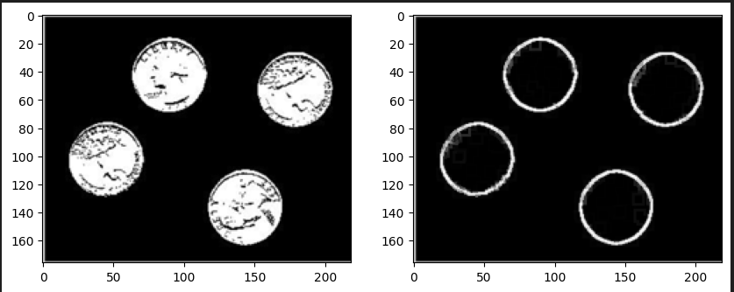

**Task 2**

image = cv2.imread('lines.png', cv2.IMREAD_GRAYSCALE)

horizontal_kernel = cv2.getStructuringElement(cv2.MORPH_RECT, (11, 3))

vertical_kernel = cv2.getStructuringElement(cv2.MORPH_RECT, (3, 11))

horizontal_opening = cv2.morphologyEx(image, cv2.MORPH_OPEN, horizontal_kernel)

vertical_opening = cv2.morphologyEx(image, cv2.MORPH_OPEN, vertical_kernel)

plt.figure(figsize=(15, 5))

plt.subplot(1, 3, 1)

plt.imshow(image, cmap='gray')

plt.subplot(1, 3, 2)

plt.imshow(horizontal_opening, cmap='gray')

plt.subplot(1, 3, 3)

plt.imshow(vertical_opening, cmap='gray')

plt.show()

**Task 3**

image = cv2.imread('image.png', cv2.IMREAD_GRAYSCALE)

_, binary_image = cv2.threshold(image, 0, 255, cv2.THRESH_BINARY_INV + cv2.THRESH_OTSU)

kernel_line = cv2.getStructuringElement(cv2.MORPH_RECT, (50, 1))

dilated_line = cv2.dilate(binary_image, kernel_line)

num_lines, _ = cv2.connectedComponents(dilated_line)

kernel_word = cv2.getStructuringElement(cv2.MORPH_RECT, (10, 1))

dilated_word = cv2.dilate(binary_image, kernel_word)

num_words, _ = cv2.connectedComponents(dilated_word)

print(f"Number of lines: {num_lines}")

print(f"Number of words: {num_words}")

cv2.imshow("Binarized Image", binary_image)

cv2.imshow("Dilated Lines", dilated_line)

cv2.imshow("Dilated Words", dilated_word)

cv2.waitKey(0)

cv2.destroyAllWindows()

**Task 4**

Create an image through paint, snipping or even your mobile. The image should have a white background and your name written in it as foreground. Detect the text in the image and make a bounding box around it is using morphological operations.

import cv2

import numpy as np

import matplotlib.pyplot as plt

image = cv2.imread('name.png', cv2.IMREAD_GRAYSCALE)

_, binary_image = cv2.threshold(image, 0, 255, cv2.THRESH_BINARY_INV + cv2.THRESH_OTSU)

kernel = cv2.getStructuringElement(cv2.MORPH_RECT, (15, 15))

dilated_image = cv2.dilate(binary_image, kernel)

contours, _ = cv2.findContours(dilated_image, cv2.RETR_EXTERNAL, cv2.CHAIN_APPROX_SIMPLE)

bounding_box_image = cv2.cvtColor(image, cv2.COLOR_GRAY2BGR)

for contour in contours:

    x, y, w, h = cv2.boundingRect(contour)

    cv2.rectangle(bounding_box_image, (x, y), (x+w, y+h), (0, 255, 0), 2)

fig, axes = plt.subplots(1, 3, figsize=(15, 5))

axes[0].imshow(binary_image, cmap='gray')

axes[0].set_title('Binary Image')

axes[0].axis('off')

axes[1].imshow(dilated_image, cmap='gray')

axes[1].set_title('Dilated Image')

axes[1].axis('off')

axes[2].imshow(cv2.cvtColor(bounding_box_image, cv2.COLOR_BGR2RGB))

axes[2].set_title('Bounding Box Image')

axes[2].axis('off')

plt.tight_layout()

plt.show()

